Cro-Am Constitution

The following is Cro-Am’s official logo:

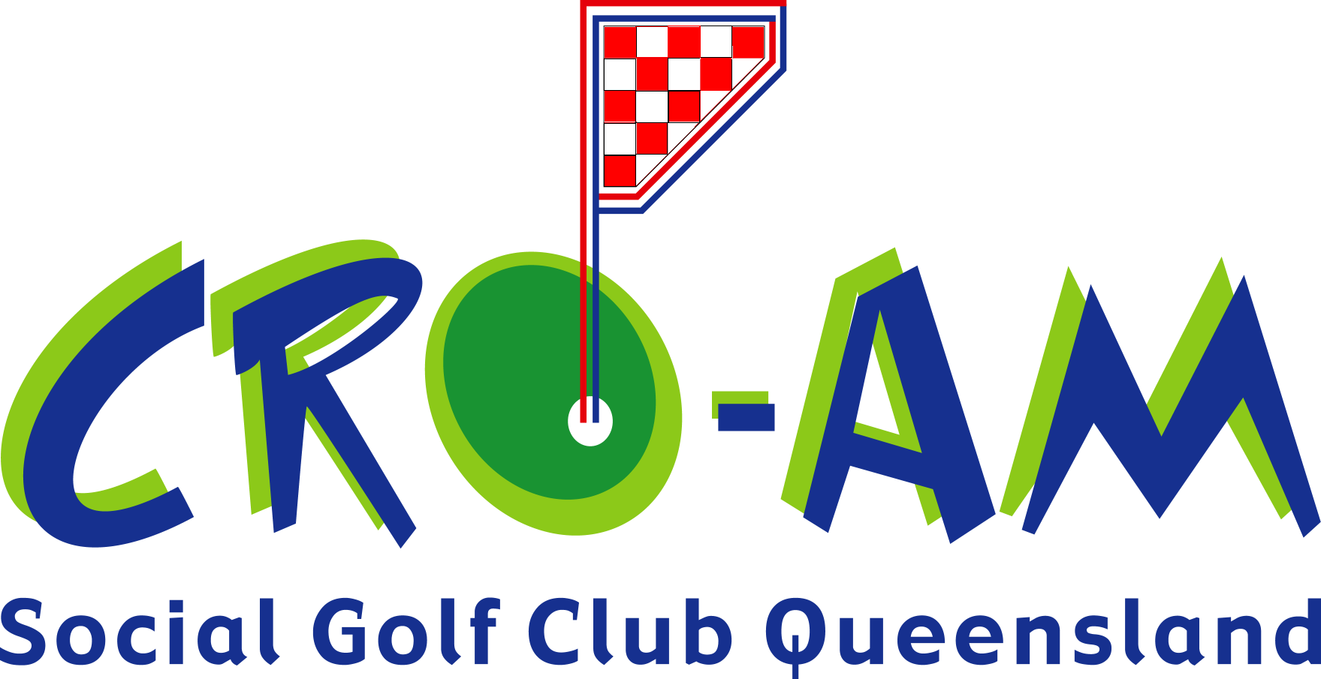

Cro-Am is a non-profit organisation and is independent from any other organisation.

Cro-Am was established to promote golf amongst the Croatian community.

Membership is open to any person regardless of race, religion, sex or age.

Cro-Am operates as a Social Golf Club and is registered with the Queensland Golf Union (QGU No. 22001).

All Grade Handicaps are calculated according to Australian Golf Union (Australian Handicapping System) with the exception that 36 be the maximum instead of 27.

The foundation members are:

Nikola Brac
Flavio Bukarica
Miroslav Bukarica
Robert Ecimovic
Steve Grabovac
Robert Marinov
Sam Mesaric
Fabian Milic

The foundation members voted on the following structure and included an additional representative to be included for Gold Coast members.

President Sam Mesaric
Vice-President Robert Marinov
Treasurer Fabian Milic
Secretary Miroslav Bukarica
Handicapper Nikola Brac
Starter Steve Grabovac
Committee Members: Flavio Bukarica
Robert Ecimovic
Joe Stipancic

Committee members have lifetime right to serve on the committee, in their current or other position/s within the committee.

The committee will review positions annually and may elect to change roles within the committee.

Replacement of a Committee member:

- will occur when a committee member resigns from the committee and notifies the rest of the committee by written notice;
- will occur due to death or mental incapacity; and
- shall be nominated by the majority of members and will be accepted only when approved by the committee.

The committee will be responsible for the running of the club and resolve any outstanding issues as they arise. A majority vote by the committee shall decide any matters of dispute.

Should a committee vote be drawn, then, the President shall have the casting vote.

The committee may delete, add or amend the constitution only when the vote obtains a 3/4 majority.

Cro-Am membership is based on an annual fee that will be determined by the committee. (Currently $40.00)

Members only are entitled to prizes. Visitors and day sponsors will not be eligible for any prize.

Visitors may play with Cro-Am at the discretion of the Secretary and the Golf Club of the day. This is due to restrictions on Tee-Off numbers and bookings.

